**BIS 425 – Information Systems Development Project**

Assignment 1

* Pet Class OOP

Dude Date: January 28, 2016

By: Ryan Grysen

1. Design View
2. PetForm

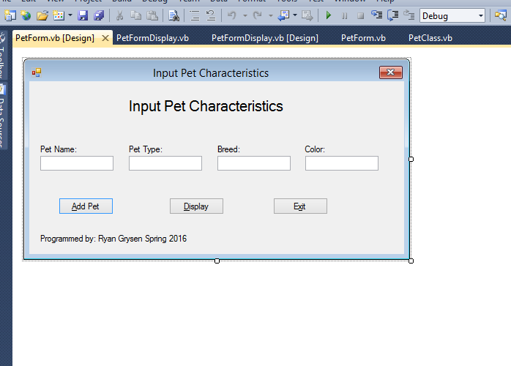

b. PetFormDisplay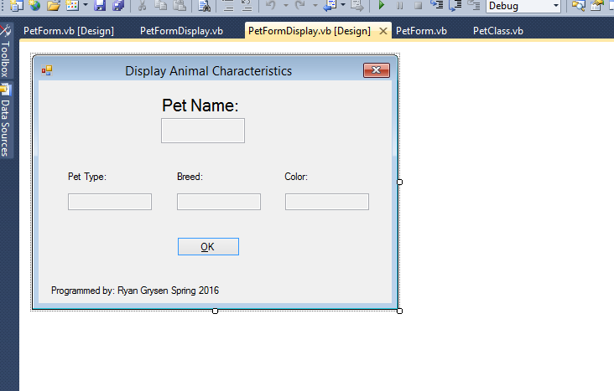

c. Solution Explorer

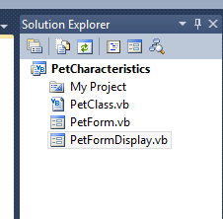

2. Execution Views

a. Input values into PetForm

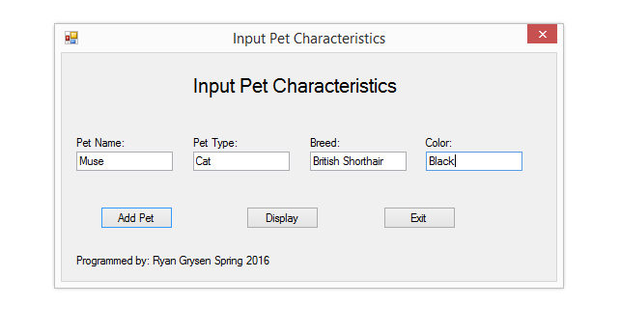

b. Execute “Add Pet” button

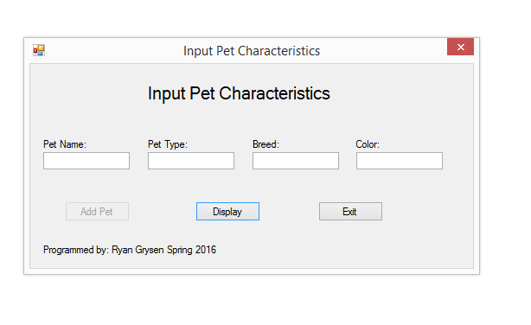

c. Execute “Display” Button

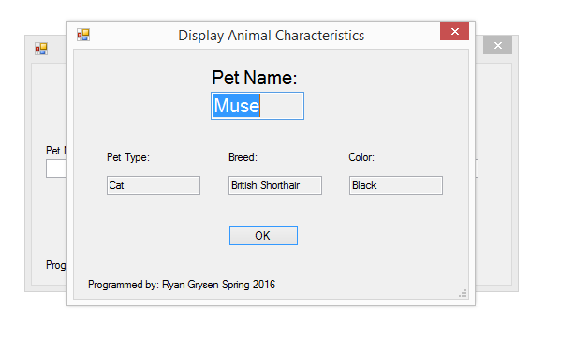

d. Error for not including an attribute

(my laptop wont let me take screenshots, so I had to use the snipping tool. I could not get the message to display at the same time. It reads “Please enter a name for your pet.” When you hover over the exclamation point.)

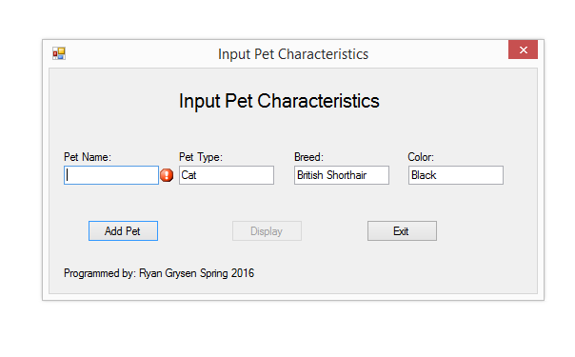

1. Codes

**Pet Class**

1. 'Project: PetCharacteristics
2. 'Programmer: Ryan Grysen
3. 'Date: January 28, 2016
4. 'Class: Pet Class
5. 'Description: this class contain all the properties of your Pet. This is the class that contains all business logic. Private variables/constants are available to and used by this class only. Properties are used to communicate with other objects outside of the class.
6. Public Class PetClass
7. Private NameString As String
8. Private TypeString As String
9. Private BreedString As String
10. Private ColorString As String
11. Sub New(ByVal NameIn As String, ByVal TypeIn As String, ByVal BreedIn As String, ByVal ColorIn As String)
12. 'set the property values
13. Name = NameIn
14. Type = TypeIn
15. Breed = BreedIn
16. Color = ColorIn
17. End Sub
18. Property Name() As String
19. Get
20. Return NameString
21. End Get
22. Set(ByVal Value As String)
23. If Value <> "" Then
24. NameString = Value
25. Else
26. Dim ex As New ApplicationException("Please enter a name for your pet.")
27. ex.Source = "Name"
28. Throw ex
29. End If
30. End Set
31. End Property
32. Property Type() As String
33. Get
34. Return TypeString
35. End Get
36. Set(ByVal Value As String)
37. If Value <> "" Then
38. TypeString = Value
39. Else
40. Dim ex As New ApplicationException("Please enter your pet's type.")
41. ex.Source = "Type"
42. Throw ex
43. End If
44. End Set
45. End Property
46. Property Breed() As String
47. Get
48. Return BreedString
49. End Get
50. Set(ByVal Value As String)
51. If Value <> "" Then
52. BreedString = Value
53. Else
54. Dim ex As New ApplicationException("Please enter your pet's breed.")
55. ex.Source = "Breed"
56. Throw ex
57. End If
58. End Set
59. End Property
60. Property Color() As String
61. Get
62. Return ColorString
63. End Get
64. Set(ByVal Value As String)
65. If Value <> "" Then
66. ColorString = Value
67. Else
68. Dim ex As New ApplicationException("Please enter your pet's color.")
69. ex.Source = "Color"
70. Throw ex
71. End If
72. End Set
73. End Property
74. End Class

**Pet Form**

1. 'Project: PetCharacteristics
2. 'Programmer: Ryan Grysen
3. 'Date: January 28, 2016
4. 'Class: PetForm
5. 'Description: This class contains all the properties of my Pet From
6. Public Class PetForm
7. Private ThePet As PetClass
8. ReadOnly Property CompletedPet() As PetClass
9. Get
10. Return ThePet
11. End Get
12. End Property
13. Private Sub AddPetButton_Click(sender As System.Object, e As System.EventArgs) Handles AddPetButton.Click
14. 'set the properties for Pet
15. Try
16. ThePet = New PetClass(NameTextBox.Text, TypeTextBox.Text, BreedTextBox.Text, ColorTextBox.Text)
17. clear()
18. DisplayButton.Enabled = True
19. AddPetButton.Enabled = False
20. Catch ex As Exception
21. Select Case ex.Source
22. Case "Name"
23. MainErrorProvider.SetError(NameTextBox, ex.Message)
24. With NameTextBox
25. .SelectAll()
26. .Focus()
27. End With
28. 'copy this catch to end with for display
29. End Select
30. End Try
31. End Sub
32. Private Sub DisplayButton_Click(sender As System.Object, e As System.EventArgs) Handles DisplayButton.Click
33. 'Display the properties of the pet object in the displaypetform
34. PetFormDisplay.ShowDialog()
35. AddPetButton.Enabled = True
36. DisplayButton.Enabled = False
37. End Sub
38. Private Sub ExitButton_Click(sender As System.Object, e As System.EventArgs) Handles ExitButton.Click
39. Me.Close()
40. End Sub
41. Sub clear()
42. NameTextBox.Clear()
43. TypeTextBox.Clear()
44. BreedTextBox.Clear()
45. ColorTextBox.Clear()
46. End Sub
47. End Class

**Pet Form Display**

1. Public Class PetFormDisplay
2. Private APetClass As PetClass
3. Private Sub OkButton_Click(sender As System.Object, e As System.EventArgs) Handles OkButton.Click
4. 'close the form
5. Me.Close()
6. End Sub
7. Private Sub PetFormDisplay_Activated(ByVal sender As Object, ByVal e As System.EventArgs) Handles Me.Activated
8. 'display the values from petform
9. APetClass = PetForm.CompletedPet
10. ColorTextBox.Text = APetClass.Color
11. BreedTextBox.Text = APetClass.Breed
12. TypeTextBox.Text = APetClass.Type
13. NameTextBox.Text = APetClass.Name
14. End Sub
15. End Class